Set up Compliance as Code

Overview

Compliance as Code (CaC) is the practice of translating security best practices and regulatory compliance requirements (such as CIS Benchmarks, PCI-DSS, GDPR, or internal policies) into machine-readable, executable rules. Instead of relying on manual checks and audits after infrastructure is built, CaC allows you to automatically validate your infrastructure configurations before they are ever deployed.

Prerequisites
- Github Account
- Basic Familiarity with YAML
- Github Actions

Step 1: Create a Sample Infrastructure Code File

- Go to New.

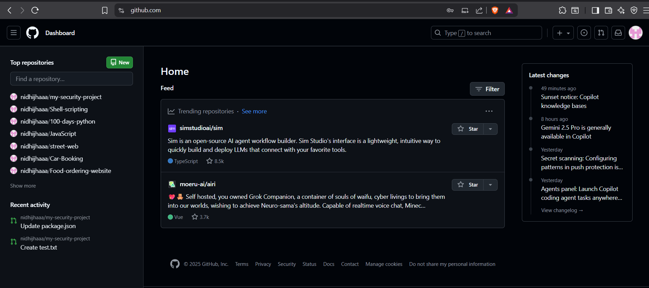

- Create new repository with any name you want.
- Make it public.
- Add README
- Click “Create Repository”
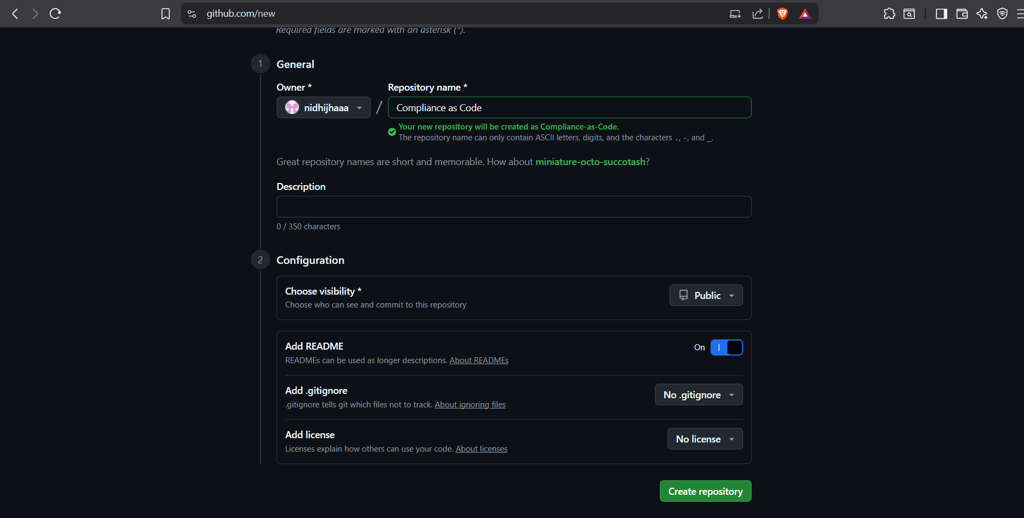

- Click the Add file button dropdown and select Create new file

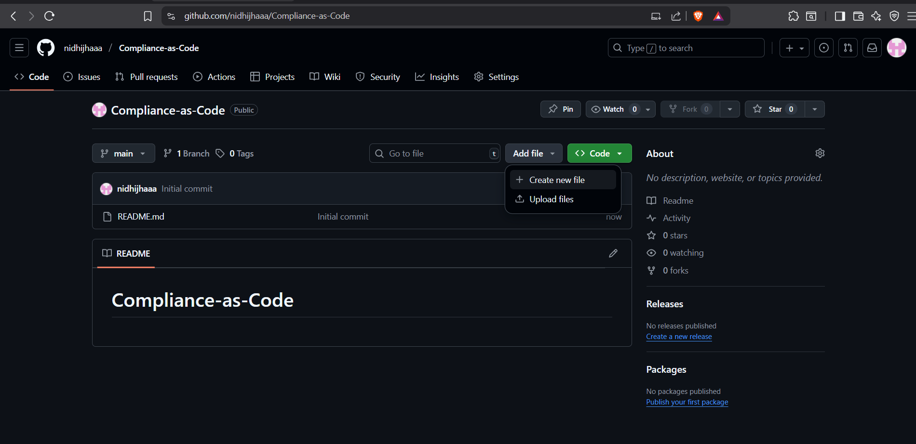

- Name the file aws_s3_bucket.tf

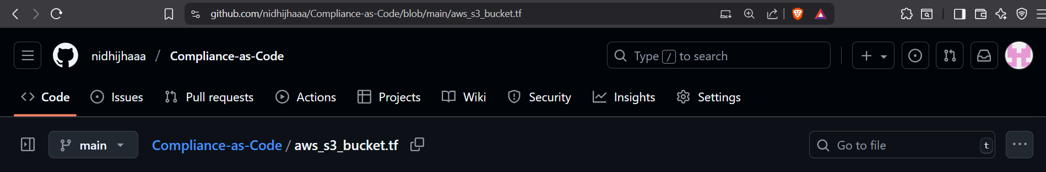

- Copy and paste the following Terraform code into the file content area. This code defines two S3 buckets, one of which is missing critical security controls.

# This file is for testing Checkov compliance scanning.
# It contains intentional misconfigurations.
provider "aws" {
region = "us-east-1"
}

# This bucket is missing encryption and versioning
resource "aws_s3_bucket" "non_compliant_data_lake" {
bucket = "my-company-non-compliant-data-12345" # Must be globally unique
}

# A better configured bucket for comparison
resource "aws_s3_bucket" "compliant_log_bucket" {
bucket = "my-company-compliant-logs-12345" # Must be globally unique
acl = "private"
tags = {
Name = "Compliant Log Bucket"
Environment = "Production"
CostCenter = "Fin-123" # Good practice tag
}

# Enable versioning to protect against accidental deletion
versioning {
enabled = true
}

# Enable default server-side encryption
server_side_encryption_configuration {
rule {
apply_server_side_encryption_by_default {
sse_algorithm = "AES256"
}
}
}
}

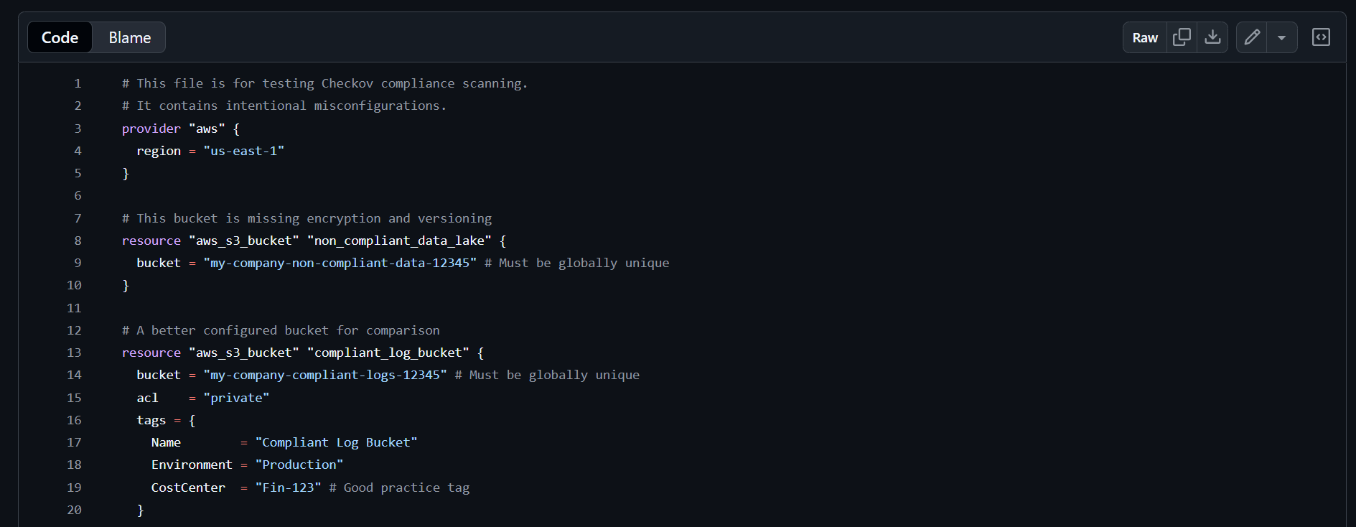
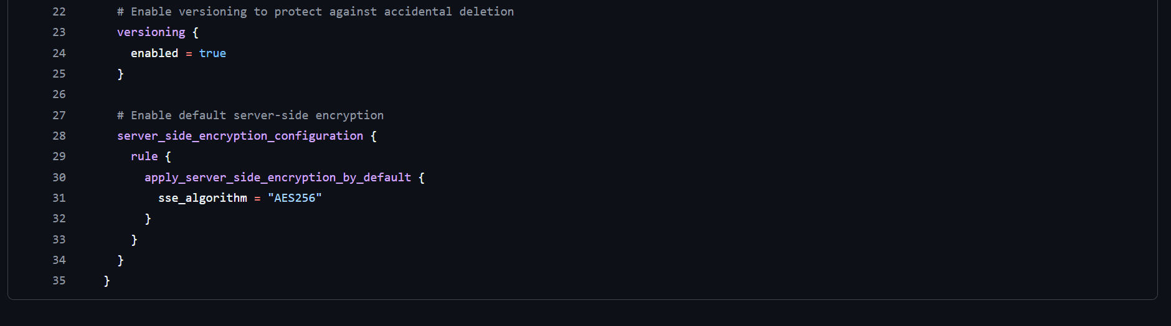

Commit the file:
- Enter a commit message: chore: add sample terraform file for checkov testing.
- Ensure Commit directly to the main branch is selected.
- Click the green Commit changes button

Explanation: The non_compliant_data_lake bucket violates multiple AWS best practices (no encryption, no versioning, missing cost center tag), which Checkov will detect. The compliant_log_bucket serves as an example of a well-configured resource.

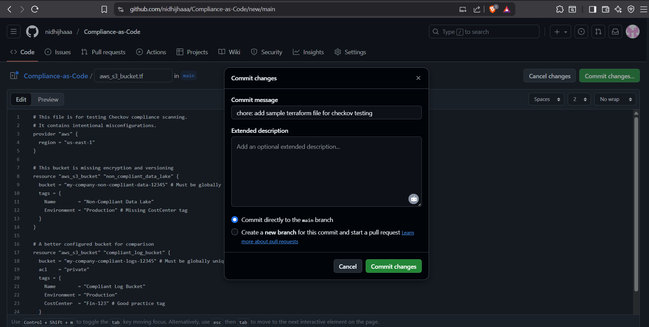

- Created successfully.

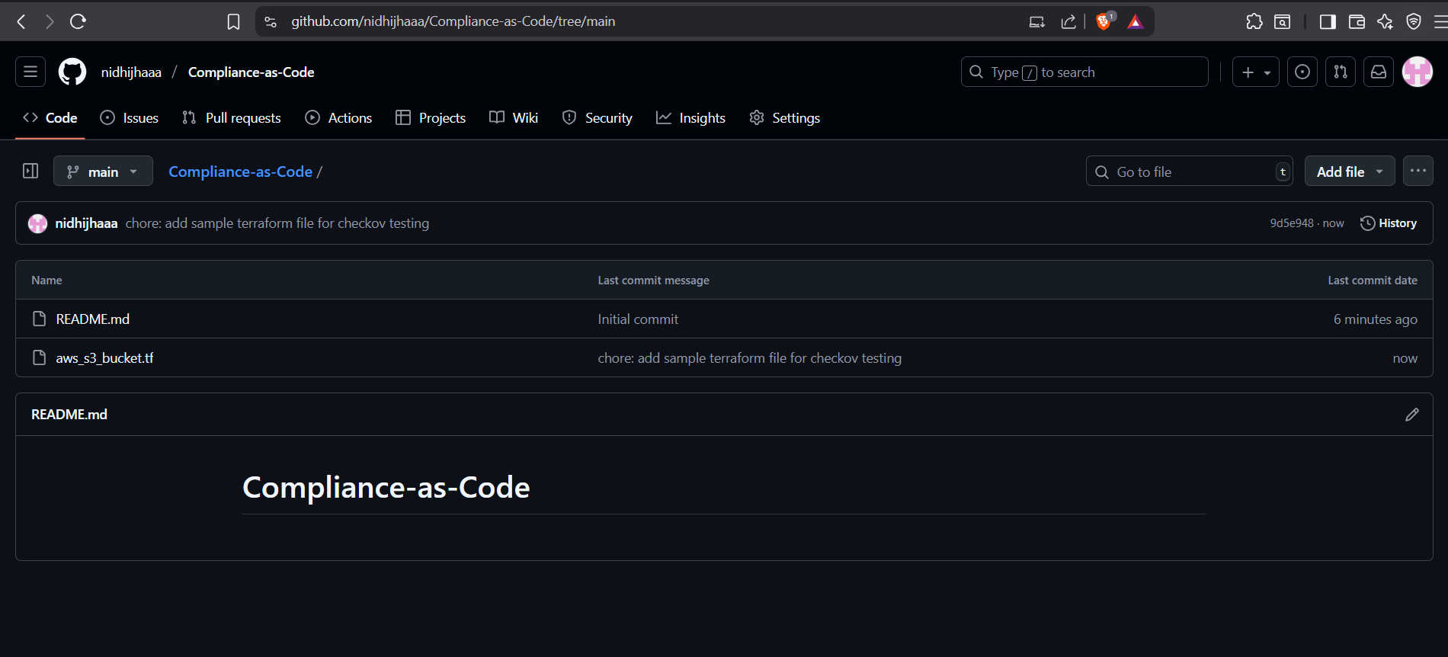

You have now created the "test subject." The non_compliant_data_lake bucket violates multiple AWS best practices (no encryption, no versioning, missing cost center tag), which Checkov will detect. The compliant_log_bucket serves as an example of a well-configured resource.

Step 2: Integrate Checkov into the CI/CD Pipeline

To add a new job to your existing GitHub Actions workflow that automatically runs Checkov on every Pull Request.

- Click the Add file button dropdown and select Create new file

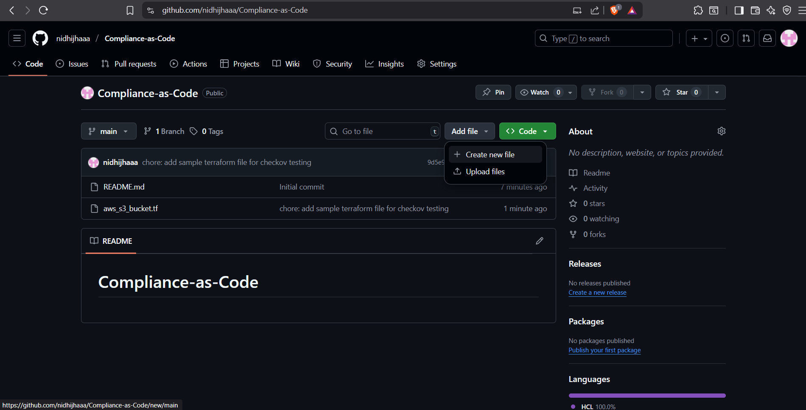

- Name the file: .github/workflows/security-scanning.yml

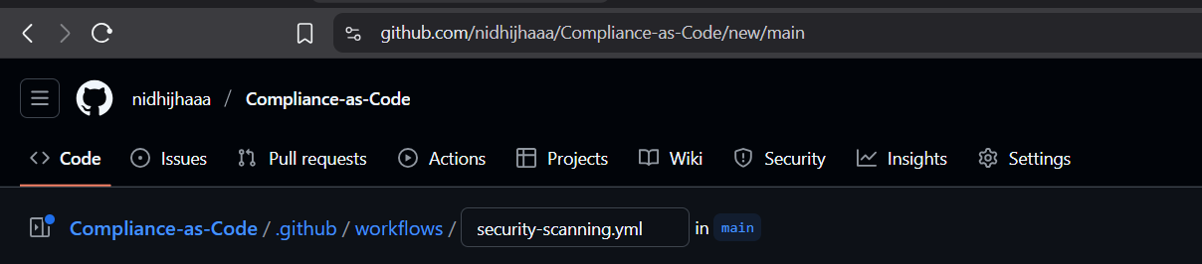

- Add the following job to the workflow

name: Security Scanning (SAST & SCA)

on:
pull_request:
branches: [ "main" ]

jobs:
dependency-scan:
runs-on: ubuntu-latest
# This job will always pass for Terraform repos since there's no package.json
steps:
- name: Checkout code
uses: actions/checkout@v4

- name: Set up Node.js
uses: actions/setup-node@v3
with:
node-version: '18'

- name: Check for package.json and skip if not found
id: check-package
run: |
if [ -f "package.json" ]; then
echo "package_exists=true" >> $GITHUB_OUTPUT
else
echo "package_exists=false" >> $GITHUB_OUTPUT
fi

- name: Install dependencies (if package.json exists)
if: steps.check-package.outputs.package_exists == 'true'
run: npm install

- name: Run Dependabot SCA scan (if package.json exists)
if: steps.check-package.outputs.package_exists == 'true'
uses: actions/dependency-review-action@v3

- name: Skip SCA scan (no package.json)
if: steps.check-package.outputs.package_exists == 'false'
run: echo "No package.json found - SCA scan skipped successfully"
# This step ensures the job passes even without Node.js dependencies

codeql-sast-scan:
runs-on: ubuntu-latest
permissions:
security-events: write
actions: read
contents: read
# This job will pass for Terraform-only repos
steps:
- name: Checkout code
uses: actions/checkout@v4

- name: Check for source code files
id: check-src
run: |
if [ -d "src" ] || [ -d "app" ] || [ -f "*.js" ] || [ -f "*.ts" ] || [ -f "*.py" ]; then
echo "source_code_exists=true" >> $GITHUB_OUTPUT
else
echo "source_code_exists=false" >> $GITHUB_OUTPUT
fi

- name: Initialize CodeQL (if source code exists)
if: steps.check-src.outputs.source_code_exists == 'true'
uses: github/codeql-action/init@v2
with:
languages: javascript

- name: Perform CodeQL Analysis (if source code exists)
if: steps.check-src.outputs.source_code_exists == 'true'
uses: github/codeql-action/analyze@v2

- name: Skip CodeQL scan (no source code)
if: steps.check-src.outputs.source_code_exists == 'false'
run: echo "No source code files found - CodeQL scan skipped successfully"
# This step ensures the job passes for Terraform-only repos

# JOB 3: Compliance as Code Scanning - THIS WILL FAIL FOR NON-COMPLIANT TERRAFORM
compliance-scan:
name: Compliance Scan (Checkov)
runs-on: ubuntu-latest
# This job will FAIL when Terraform violations are found
steps:
# Step 1: Obtain the code from the repository
- name: Checkout code
uses: actions/checkout@v4

# Step 2: Execute Checkov static analysis
- name: Run Checkov scan
uses: bridgecrewio/checkov-action@v12
with:
# Scan the entire repository for IaC files
directory: ./
# Display detailed results in the workflow log
quiet: false
# Fail the job if any compliance violations are found
fail_on: FAILURE
# A non-zero exit code from Checkov will fail this step

# Optional: Add a success message if you want (though Checkov failure will prevent this from running)
- name: Compliance check passed
if: success()
run: echo "All Terraform resources are compliant!"

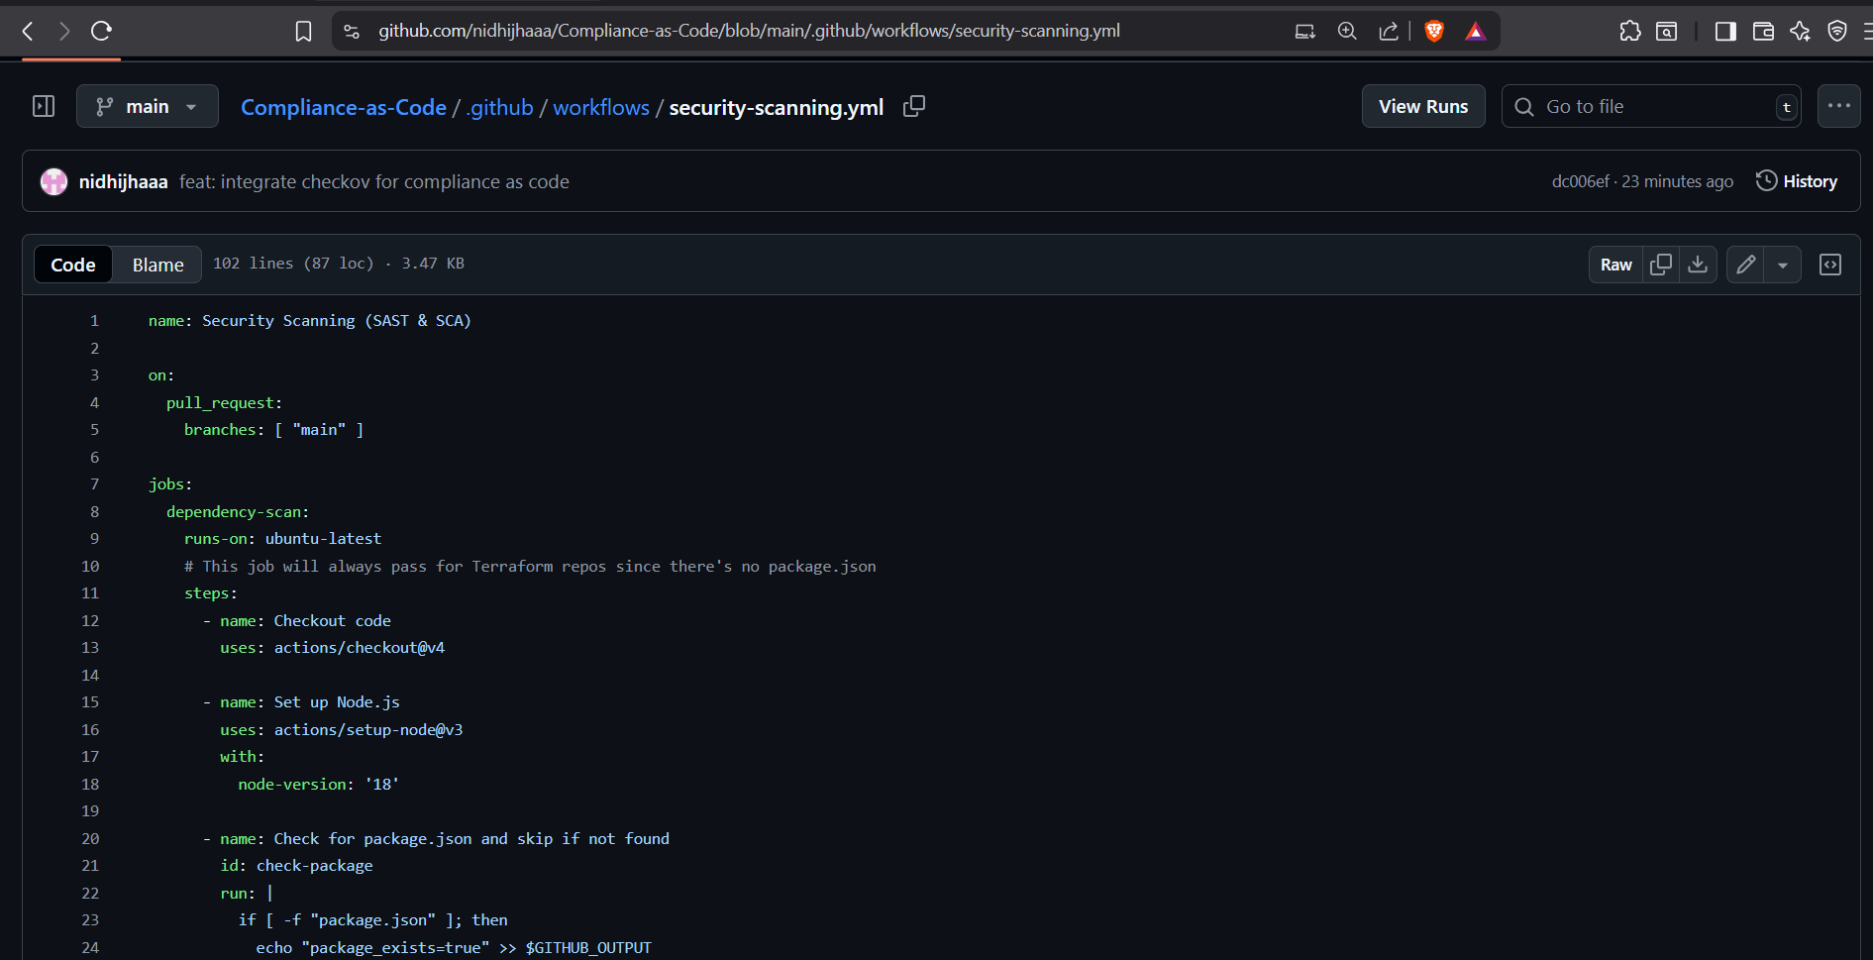
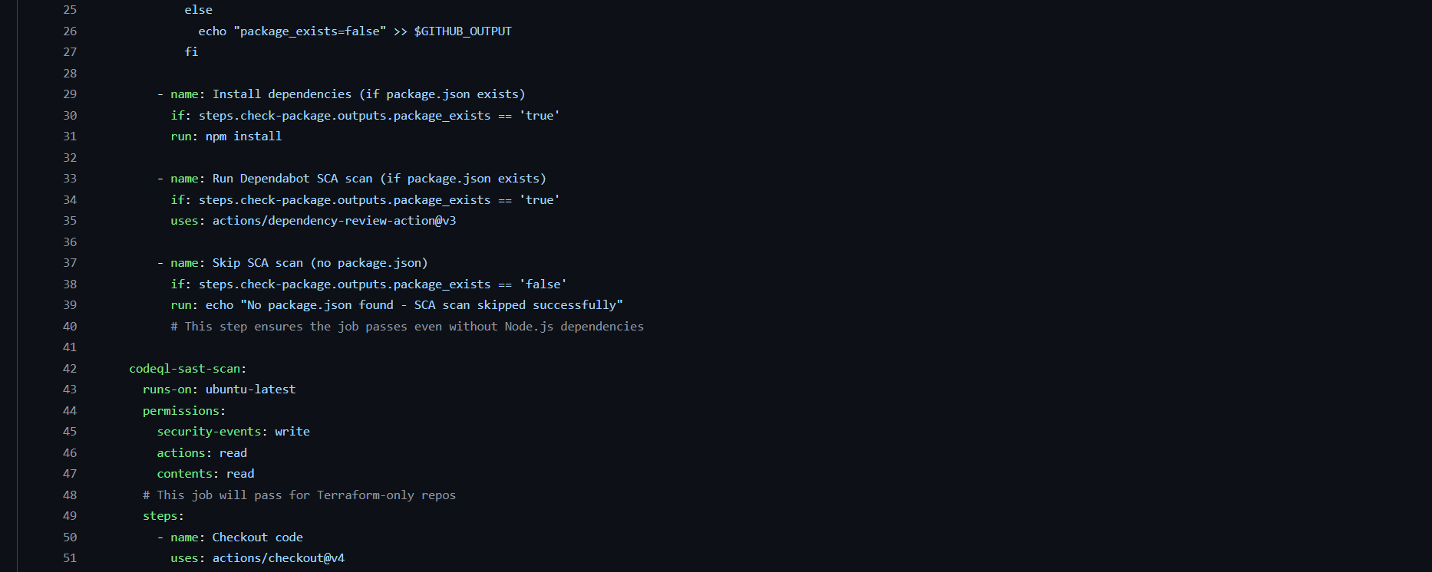
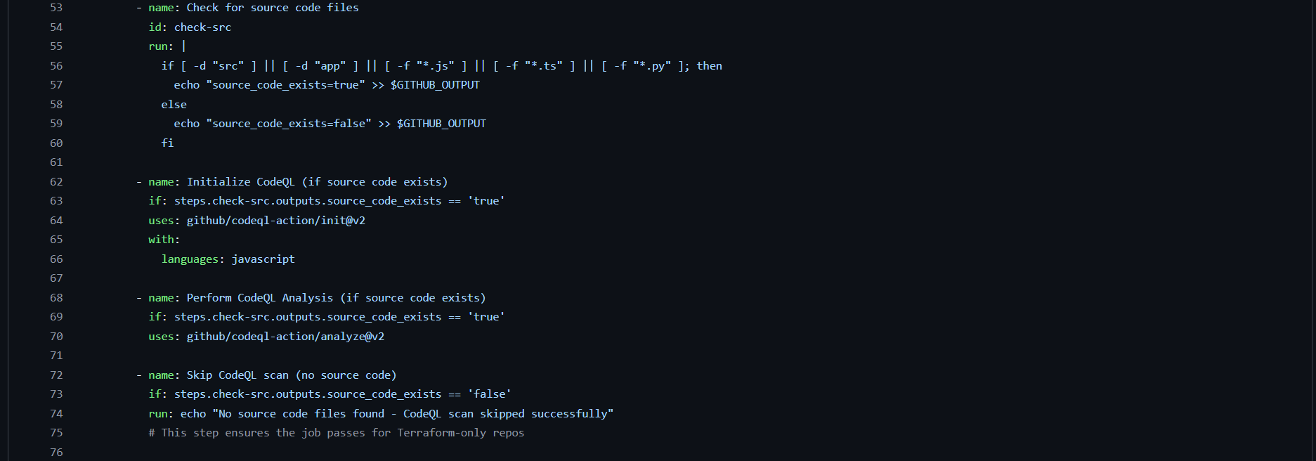
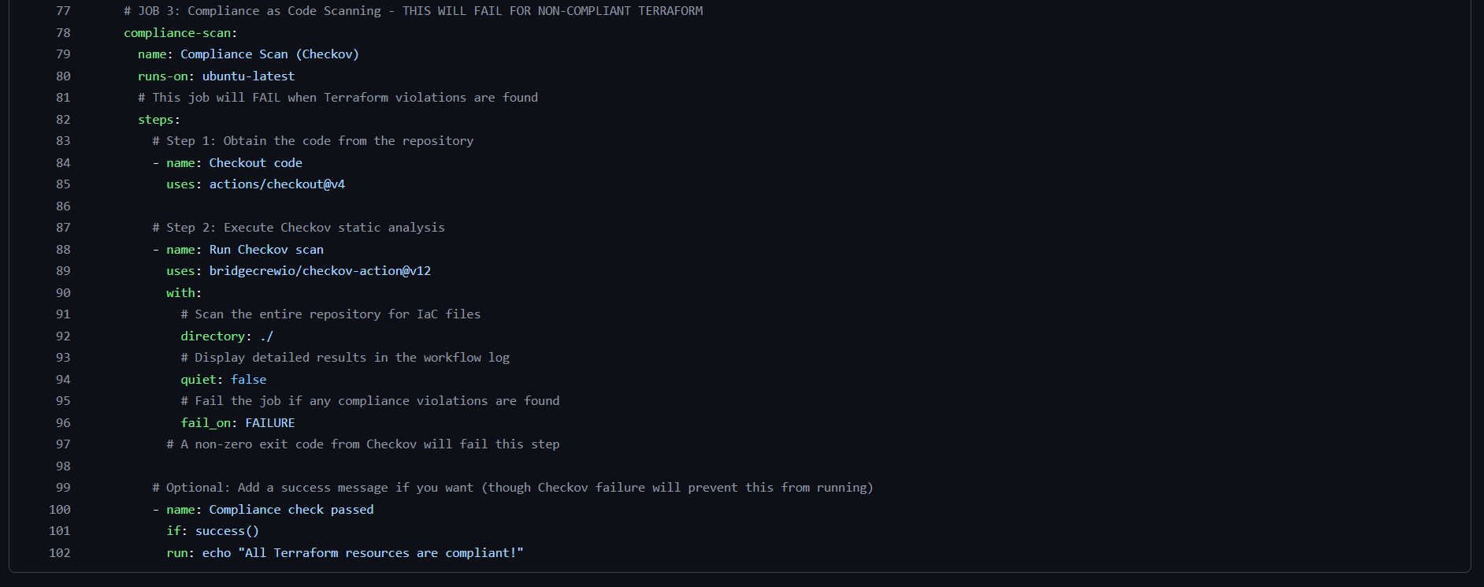

- Commit the change:
  - Enter a commit message: feat: integrate checkov for compliance as code
  - Select Commit directly to the main branch
  - Click Commit changes
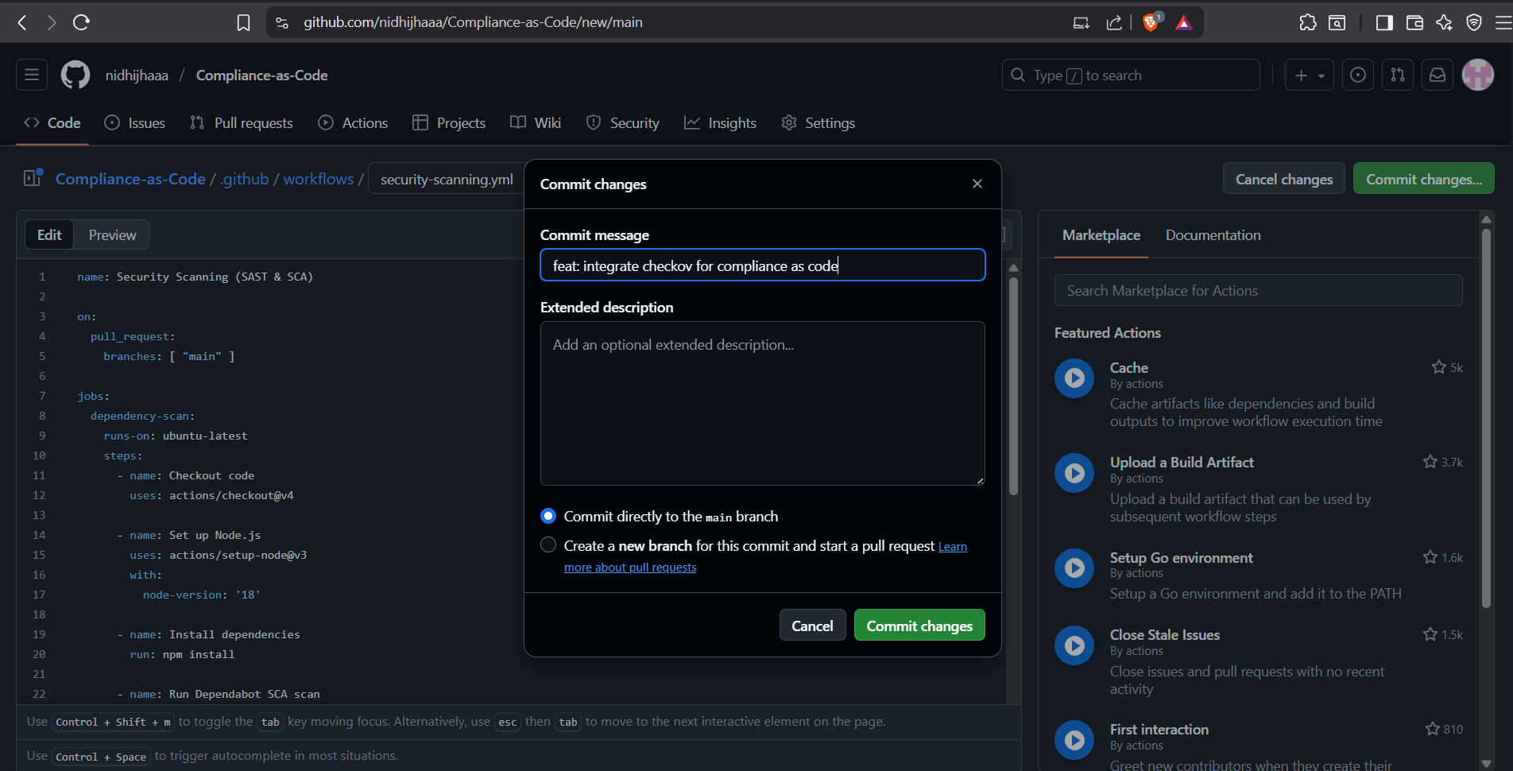

This YAML defines a new job called compliance-scan. It uses the official checkov-action from Bridgecrew. The action will scan every file in your repository for known IaC formats (like Terraform). If it finds any configurations that violate its built-in policies, it will fail the job, which in turn fails the entire workflow and blocks the associated Pull Request from being merged.

Step 3: Validate the Implementation by Testing

To verify that the Checkov integration works correctly by creating a Pull Request that should be blocked due to compliance failures.

- Edit the Terraform file to introduce a new violation:
- Go to your repository's Code tab.
- Click on the aws_s3_bucket.tf file.
- Click the pencil icon to edit it

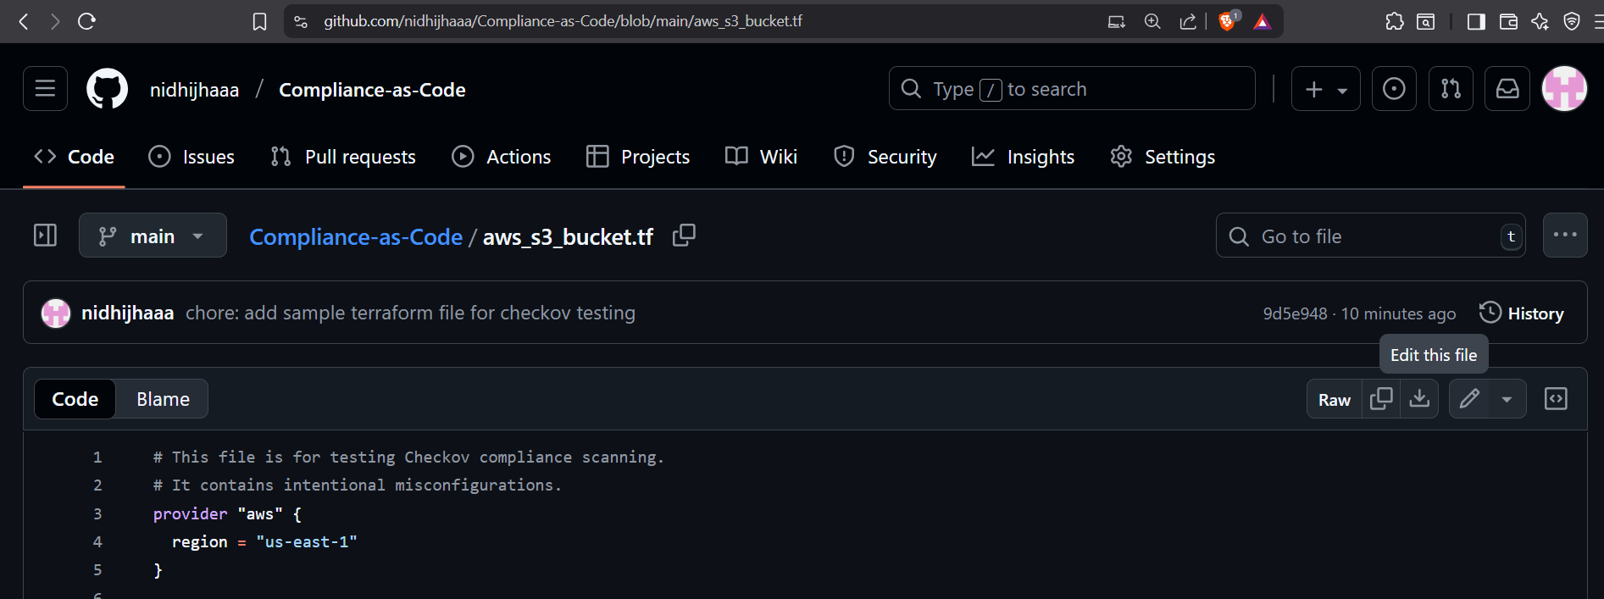

- Make a non-compliant change: Find the non_compliant_data_lake resource and delete its entire tags block.

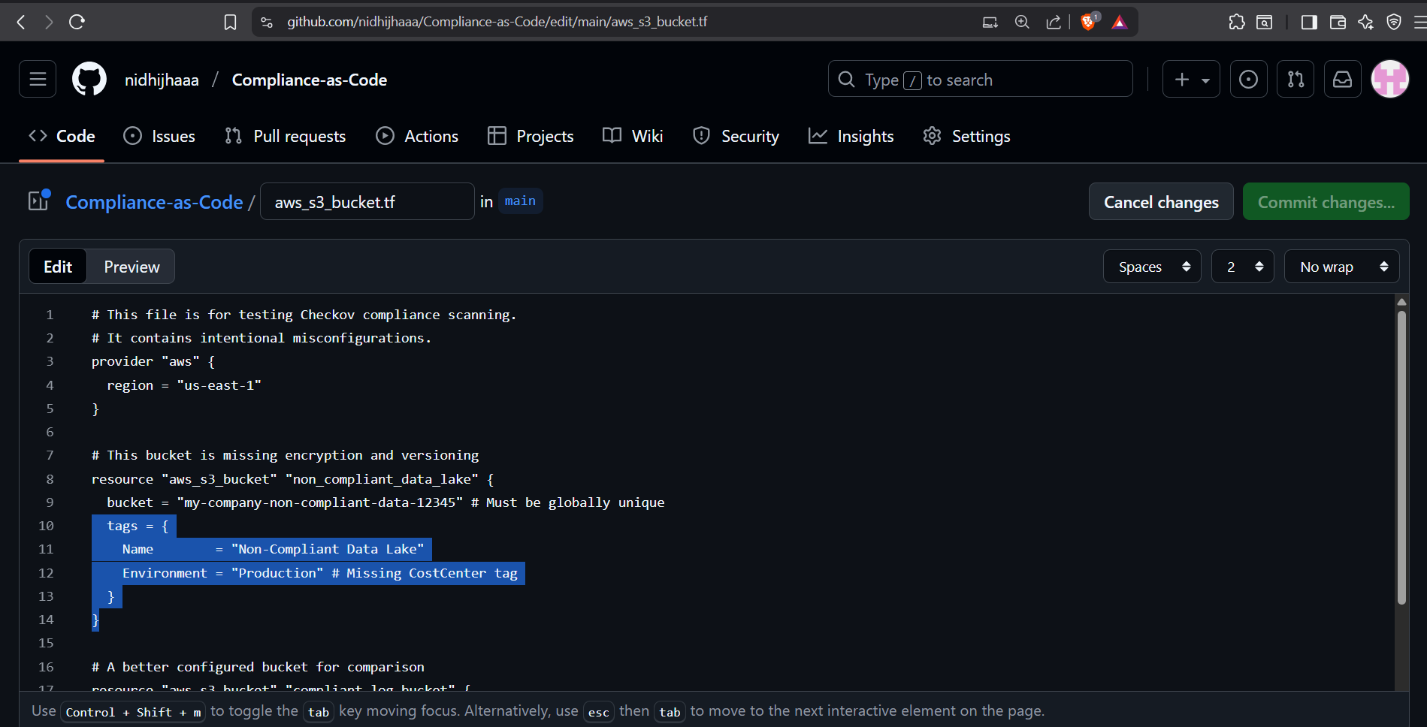

- In the commit box at the bottom, select the option that says Create a new branch for this commit and start a pull request.
- Name the new branch “test/checkov-compliance-fail”.
- Click Propose changes

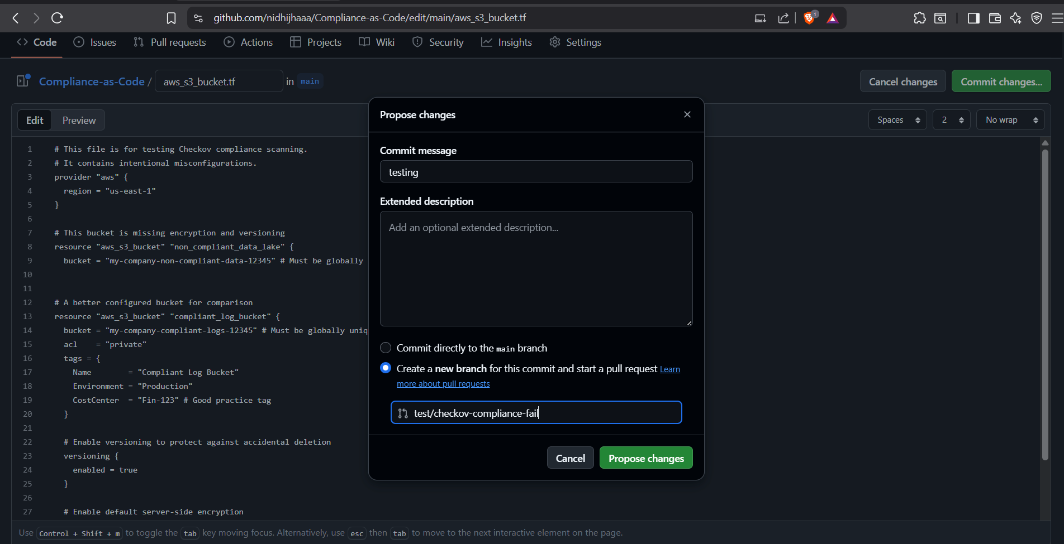

- On the following screen, click the green Create pull request button. You may add a title like "Test: Checkov Compliance Failure"

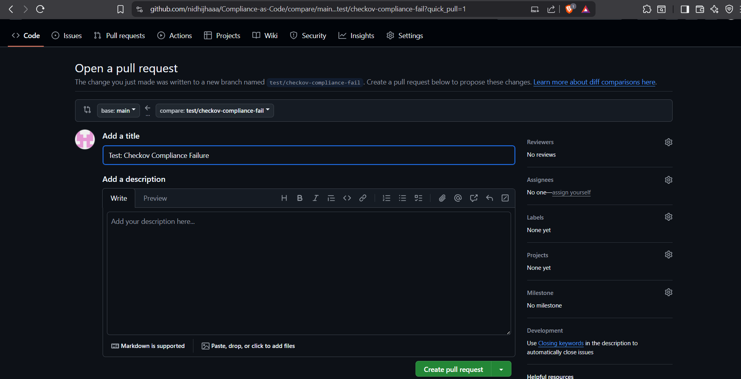

- Wait 30-60 seconds for the GitHub Actions workflow to trigger and complete.
- On the PR page, scroll down to the checks section. You will see:
  - dependency-scan (Passed)
  - codeql-sast-scan (Passed)
  - compliance-scan (Failed)

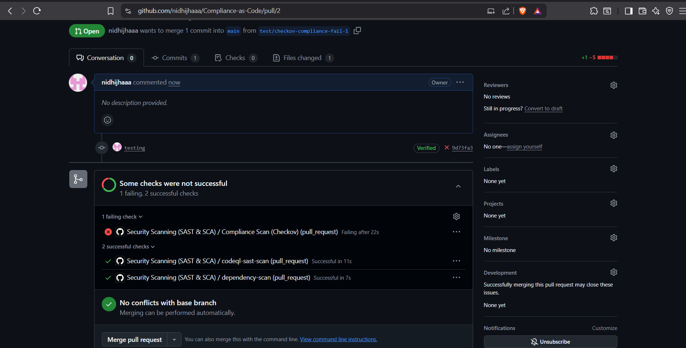

Your compliance gate is active and working. It has successfully blocked the PR because the infrastructure code does not meet security standards.

- Go to actions Click the workflow.

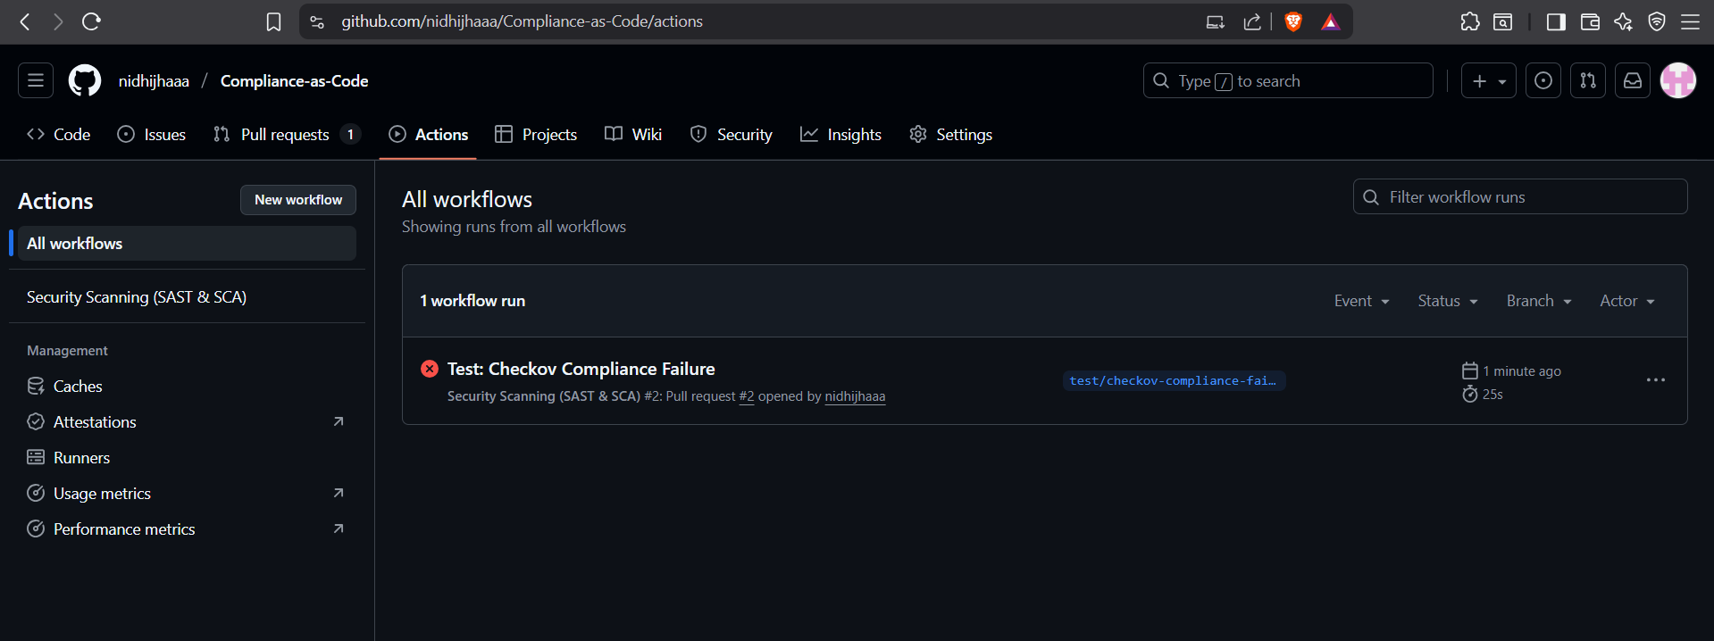

- Check the full Checkov output log.

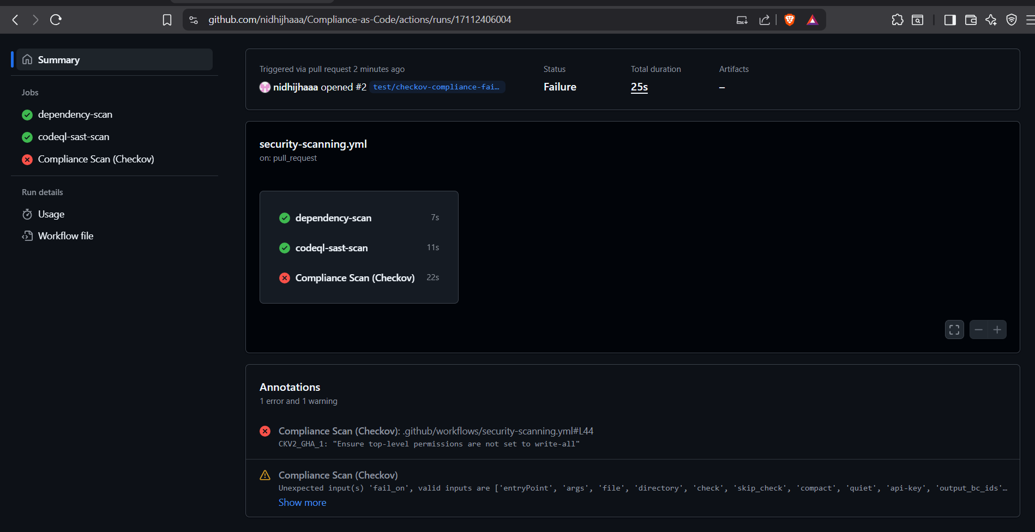

It will identify several violations for our non-compliant S3 bucket, for example:
- CKV_AWS_18: Ensure the S3 bucket has access logging enabled.
- CKV_AWS_19: Ensure the S3 bucket is encrypted.
- CKV_AWS_21: Ensure the S3 bucket versioning is enabled.
- CKV_AWS_56: Ensure S3 bucket has 'restrict_public_bucket' enabled.

Result and Gating:
- Checkov outputs a detailed report in the Actions log, showing each check that PASSED, FAILED, or was SKIPPED.
- If any FAILED checks are found, the Checkov action fails the entire compliance-scan job.
- This failure appears as a red X on the Pull Request, blocking it from being merged until the infrastructure code is fixed.
- The developer is forced to "shift left" and fix the security misconfiguration during development, before any infrastructure is ever provisioned.

Conclusion

We have successfully established a robust Compliance-as-Code framework by integrating Checkov into our CI/CD pipeline. This implementation automates infrastructure security validation and enforces organizational policies directly within our development workflow, creating an automated governance layer that prevents non-compliant Terraform configurations from progressing to production.

Key Achievements:
- Automated Compliance Scanning: Integrated Checkov for continuous infrastructure-as-code validation
- PR Quality Gates: Implemented mandatory compliance checks that block non-conforming changes
- Shift-Left Security: Identified and remediated misconfigurations during development phase
- Custom Policy Framework: Established tailored compliance policies matching organizational requirements
- Seamless Integration: Maintained development velocity while enhancing security posture

